# A Winter Union - NEW ALBUM PRESS RELEASE

# Sooner After Solstice

A Transatlantic Folk Christmas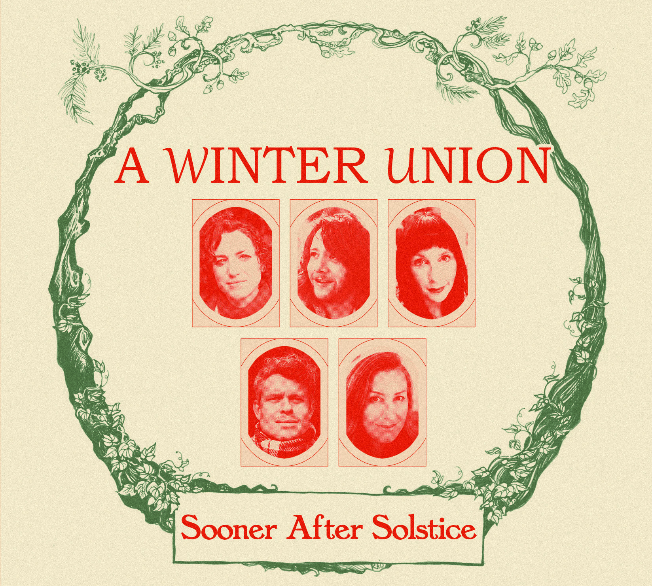

### Album Release

Artist: A Winter Union

Album: Sooner After Solstice

Release Date: 10 NOV 2023

Label: Sungrazing Records (Catalogue No. SGR201)

### Single Release

Single: Snowin’ On Raton - Out 03 NOV 2023: <https://tinyurl.com/ywnn34va>

### Album Announcement and Video Release

[Minstrels](https://soundcloud.com/awinterunion/minstrels/s-ZxWF4ZOT4ZV?si=7c06ce09baf040d4b9495933af31c54c&utm_source=clipboard&utm_medium=text&utm_campaign=social_sharing) - Premiere on Folk Radio on 18 OCT 2023: <https://youtu.be/p3MuWyuRFrw>

### Resources & Listening

Dropbox - Private album download, packshot & publicity photos: <https://shorturl.at/ioBW9>

Soundcloud Private Listening: <https://shorturl.at/fwyKU>

### About A Winter Union - Sooner After Solstice

Festive folk supergroup A Winter Union release first studio album for 7 years.

Featuring members of Gilmore & Roberts, Hannah Sanders & Ben Savage and The Willows, it’s no surprise that A Winter Union’s Sooner After Solstice showcases a band bursting with individual brilliance. Crucially though, A Winter Union produce a sound so much greater than the sum of their parts; this is a record full of the joy, passion and life - the magic captured between 5 friends in a room singing the music they love. Following some early personnel changes, the band’s line-up has been settled since 2017 and this comfort and confidence shines throughout. “We’ve long looked upon our December tour as a kind of month-long Christmas party” says Ben Savage, “There’s always such a brilliant feeling in the room at gigs around that time of year and we just feed on it… By recording lots of the record close together, live in the studio, in the winter, we did everything we could to try and can a little of that energy here.”

The band give nods to both British and American folk traditions. ‘The Trees of Old England’ sees the quintet add a new wassail to the traditional repertoire and ‘Minstrels’ sets to music Wordsworth’s poem about the rigours of music making in the depths of the British winter. Meanwhile, Jethro Tull’s ‘Ring Out, Solstice Bells’ opens the album with a transatlantic feel with mandolin and dobro riffs a-plenty; and the raucous ‘Rise Up Shepherd’ finds the band belting out gospel-tinged choruses to an earthy blues jam backing.

Whilst there is no shortage of Christmas party here, there are plenty of moments for reflection and poignancy: Jamie’s reworking of Graeme Miles’ ‘Snows Of Winter’ is a beautiful declaration of love amidst the freeze and Katriona’s ‘Raise A Candle’ offers a moment of reflection at a time of year which is so challenging for so many.

### A Winter Union - Background on Band Members

Hannah Sanders & Ben Savage spent the early part of 2023 opening for folk-rock legends Fairport Convention following their Topic Records debut “Ink Of The Rosy Morning” -

“As heartwarming as it is beguiling” MOJO

Gilmore & Roberts released new album “Documenting Snapshots” earlier in 2023 to critical acclaim with their previous work earning them 3 BBC Folk Award nominations. “Gilmore & Roberts take English folk and scuff it up with indie rock drama” - Q Magazine

The Willows rose to prominence when their transatlantic folk-rock was championed by the likes of legendary BBC DJs Mike Harding and Bob Harris. The band are busy working on their 4th studio album. ★★★★★ – “Outstanding!” - The Telegraph

### Track-Listing

1. Ring Out, Solstice Bells (3:41)

2. Minstrels (3:17)

3. Snowin’ On Raton (4:31)

4. All Bells in Paradise (4:04)

5. White Christmas Somewhere (4:15)

6. Rise Up Shepherd (3:25)

7. Snows Of Winter (6:00)

8. The Trees Of Old England (3:42)

9. Raise A Candle (4:11)

10. In The Bleak Midwinter (3:44)

11. Boxing Day (3:10)

12. I Saw Three Ships (3:56)

### Personnel

A Winter Union are:

Jade Rhiannon – Vocals, Shruti Box

Katriona Gilmore – Vocals, Mandolin, Fiddle

Jamie Roberts – Vocals, Guitar

Hannah Sanders – Vocals, Dulcimer, Guitar

Ben Savage – Vocals, Dobro, Guitar, Lapsteel

Additional musicians:

Double Bass - Ben Nicholls

Drums - Dan Day

Production, recording & mixing - Ben Savage

Mastering - Nick Cooke

Art & Design - Rachel Oakes and Chris Collins

### Songs - Additional Information

1. Ring Out Solstice Bells [Anderson]

Jethro Tull’s classic is given a transatlantic twist to open the record with a bang. There are mandolin and dobro riffs a-plenty while Hannah & Jade trade the lead vocal with all the joy and life of the band’s live shows.

2. Minstrels [Wordsworth / Rhiannon / A Winter Union]

The band’s setting of Wordswoth’s poem of the same name. As a band that has only ever toured throughout December, A Winter Union felt a real affinity with Wordsworth’s workmanlike seasonal musicians.

3. Snowin’ On Raton [Van Zandt]

Amidst the snow, 8000ft up on the Colorado-New Mexico border, Townes Van Zandt was at his bittersweet lyrical best. Ben says, “It’s part love song, part road song, and so often its imagery flashes through my mind as we take night drives mid-tour.”

4. All Bells In Paradise [Trad / Sanders / A Winter Union]

Hannah says “I have long adored the mystery and symbolism within the Corpus Christi Carol. Evocative of grail quests, healing waters and celestial music, it resonates with a sacred presence still.” This tiny scrap of our mythic heritage, found by a grocer, behind a bookcase in the nineteenth century is here reimagined by the band in all its mystical glory.

5. White Christmas Somewhere [Savage / A Winter Union]

Ben says “Touring through December, we spend a lot of our time praying for it not to snow! Truth be told though when those heavy clouds come in of an evening, I’m still very much the lad who’s opening the curtains and hoping for that magical covering!”

6. Rise Up Shepherd [Trad / Roberts / A Winter Union]

Recorded live in the studio with a view to capturing the magic and power of joyous seasonal chorus singing! This American spiritual lends itself perfectly to a gospel-tinged arrangement.

7. Snows Of Winter [Miles]

Jamie says “Graeme Miles was a folk singer and songwriter from the North East who wrote many wonderful songs, a lot of which have now become mainstays of folk clubs up and down the country. I first heard this beautiful song being sung by a floor singer at a folk club and instantly fell in love with it.”

8. The Trees Of Old England [Savage / A Winter Union]

Ben says “I’ve made cider annually with a few mates for the past 18 years and I’m continually struck by the abundance of produce we’re lucky to be amongst in England - I’ve yet to pay for a single apple! The cider year has a beautiful rhythm to it and crucially, plenty of opportunities to have a bloody good time - I did my best to document one such moment here!”

9. Raise A Candle [Gilmore / A Winter Union]

Katriona says “A song about the strange time-warp period between Christmas and New Year – reflecting on the previous twelve months and thinking ahead to the year yet to come, finding reasons to be grateful and things that need to change. Written for anyone who finds the festive season difficult, for any reason.”

10. In The Bleak Midwinter [Trad / Sanders / A Winter Union]

Led by Hannah on Appalachian Dulcimer, and later joined by gentle Fiddle, Dobro and Guitar ‘In The Bleak Midwinter’ is perhaps the best-known track on the record. Holst’s beautiful tune is enduring and requires all the restraint and care the band pays to it in this intimate live studio instrumental.

11. Boxing Day [Johnson]

Jamie says “I first heard this powerful Robb Johnson song on a recording of the late great Roy Bailey singing it as part of the politically driven folk super-group The Band Of Hope. Despite it first being recorded in the early '90s, the lyrics still ring very true today!”

12. I Saw Three Ships [Trad / Rhiannon / A Winter Union]

Jade says “This is a sparse brooding arrangement of this well-loved carol, depicting tales of boats, camels or skulls, depending on who’s listening. Katriona then weaved in an original instrumental called ‘The Finchingfield Festive Rabbit’ aptly named after its debut airing amongst a brilliant audience.

### Album Launch Tour Dates

|  |  |  |
| --- | --- | --- |
| **Date** | **Town** | **Venue** |
| 1st Dec | Otley | Courthouse Theatre |
| 2nd Dec | Stratford-Upon-Avon | Playhouse |
| 5th Dec | Norwich | Playhouse |
| 6th Dec | Burton Upon Trent | Brewhouse Arts |
| 7th Dec | Bath | Chapel Arts |
| 8th Dec | Whitchurch | Talbot Theatre |
| 9th Dec | Sheffield | The Greystones |
| 10th Dec | Saltaire | The Live Room |
| 12th Dec | Bristol | St George’s |
| 13th Dec | London | King Place |
| 14th Dec | Winchester | The Arc |
| 15th Dec | Cambridge | Storey’s Field |
| 16th Dec | Barton-Upon-Humber | The Ropewalk |
| 17th Dec | Nottingham | The Poppy & Pint |
| 18th Dec | Gateshead | The Sage |